**RC & Regular Workflow**

Refer the below for RC & Regular :



1.RC & Regular WF flow can be created manually or from API, when created from API , change the WF type as RC & Regular while editing the EditWO form.

2.In EditWO from , goto RC media and provide the RC media (Rought cut: will always be .mp4 format) , Provide the subtitle and dubbing if required.

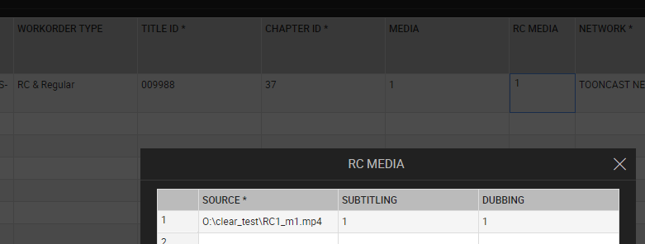

3.Notify & Start the WF ,there will be no media Id for Rough cut .Assign/pick the subtitle and dubbing tasks to the respective users. There will be no upload & mark as complete.

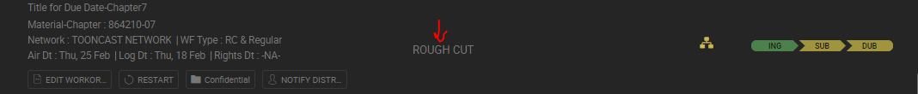

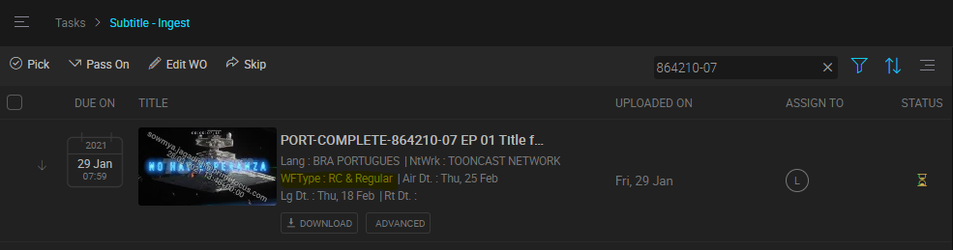

4.Notify distributor will appear again for the Regular WF , click on Notify distributor , Edit the WO and fill the Media details (same as Regular ) & start the WF. Perform QC on Media flow. When media level subtitle & dubbing task gets created , RC’s subtitle and dubbing task gets automatically completed (status will be changed to completed i.e green status ).

5.Below are some the validations:

i.RC should always be .mp4 , validation on start WF.

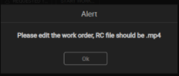

ii.When WF is selected as RC & Regular & RC media is not given in EditWO , below is the validation on startWF

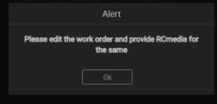

iii.When RC media details mismatches with the media details for subtitle & Dubbing then below is the validations on startWF of media flow.

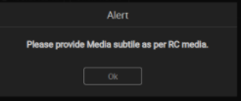 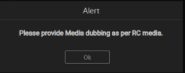

Media flow will contain same as Regular WF , for both Virtual and non-Virtual flows.

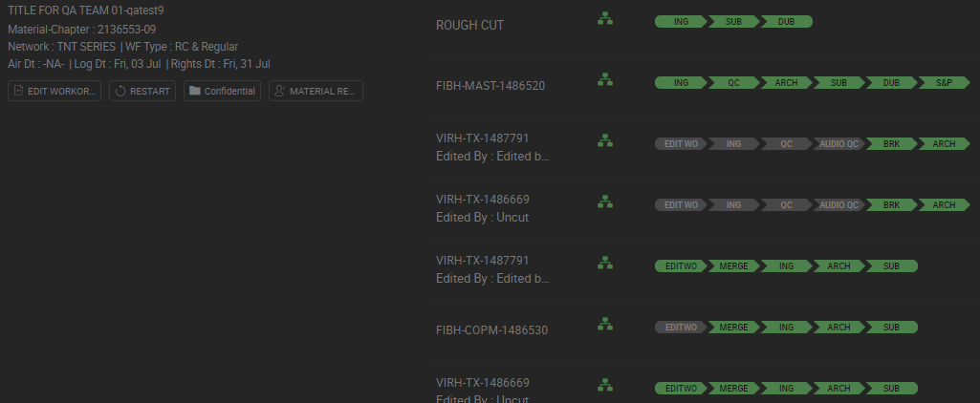

**Express flow:**

* After Editing the EditWO form , Start the WF CLEAR will make calls to Aleph to create the TX Media and submit the segment and TC information and mark Ingest as Yes and technical status as ‘PFO’.

{

"payload": {

**"mediaMaterialId": "FIBH-TX-1488658-147871-44",**

**"technicalStatus": "PFO",**

"clearUserId": "har1Clear",

"mamCredentials": {

"clientId": "MAM",

"clientSecret": "MAM",

"userId": "srv_clearwebservices",

"password": "Alephclear17",

"encrypted": false

}

}

}

Similarly Ingest Ids will be generated for the number of segments given in Edition🡪Segment

* When QC is made fail , then express flow should make use of same media id , Refer below:

TL-5497-CR10- Ability to re-use Media Ids in case of Express WF re-delivery

* There will no AQC in Express flow.

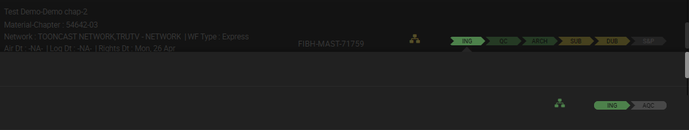

* If QC fail is done , there won’t be QC Override options , WF will restart & new media Id will be created.

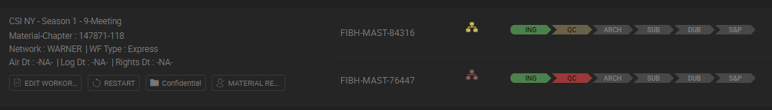

* In EditWO 🡪Edition ,provide segment details for PE task, while performing BSK task same number of segments should be created

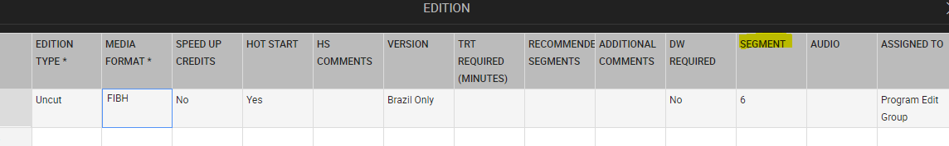

* There won’t be S&P task created. If PE requires to be done on versions , then in EditWO🡪Edition versions can be selected manually , This will create versions for PE . (Uncut & versions can be given in edition)



* Express flow holds same for other scenarios as that of Regular .

**S&P TBD flow:**

1.S&P TBD is similar to Regular flow except that S&P user should be able to select/deselect Uncut in S&P version popup.

2.When WO is created , select WF type as ‘S&P TBD’, and enter the media details.

3. S&P TBD flow holds same for other scenarios as that of Regular for both Virtual & Non-Virtual.

**QC & Ingest with S&P:**

1.Create WO manually or from API.

2.This flows involves ING🡪AQC🡪QC🡪Archival🡪Rating

3.Media type will always be TX ( multiple segments ingest ), Playlist should be created for the multiple segments created.

4.AQC override and QC override functionality is same as Regular

5.After Archival(DIVA, SNELL , INETSAT) is completed , Rating will be created and rating Notification should be triggered for S&P team perform rating.

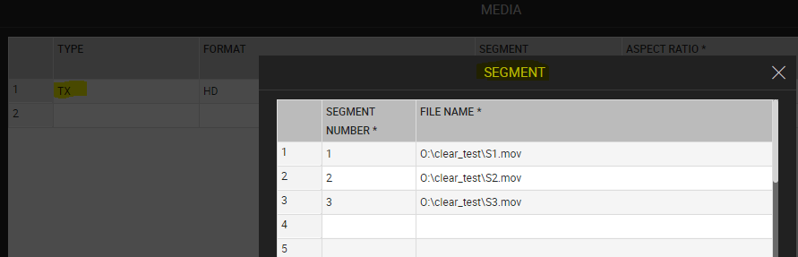

QC:

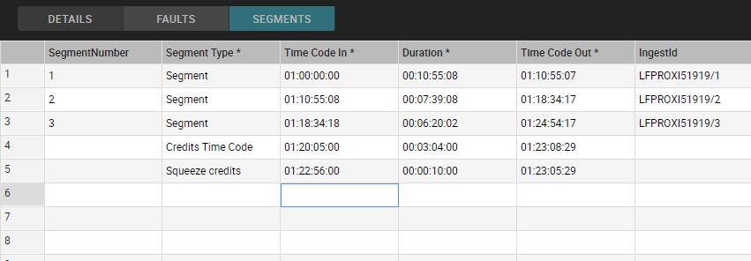

QC Payload:

{

"payload": {

"mediaMaterialId": "FIBH-TX-1694315-2148118-4",

"aspectRatio": "169FF",

"standard": "NTSC",

"technicalStatus": "QKK",

"hotstart": "Y",

"hotstartComments": "HS in QC with Ing S&P ",

"editedBy": "",

"versionType": "",

"segments": [

{

"number": 1,

"timeCodeIn": "01:00:00:00",

"timeCodeOut": "01:10:55:07",

"duration": "00:10:55:08",

"squeezes": []

},

{

"number": 2,

"timeCodeIn": "01:10:55:08",

"timeCodeOut": "01:18:34:17",

"duration": "00:07:39:08",

"squeezes": []

},

{

"number": 3,

"timeCodeIn": "01:18:34:18",

"timeCodeOut": "01:24:54:17",

"duration": "00:06:20:02",

"creditTypeId": "2",

"creditTimeCodeIn": "01:18:54:00",

"creditTimeCodeOut": "01:23:18:29",

"creditDuration": "00:04:25:00",

"squeezes": [

{

"typeId": "SQZ1",

"timeCodeIn": "01:20:33:00",

"timeCodeOut": "01:22:33:29",

"duration": "00:02:01:00"

}

]

}

],

"audios": [

{

"channel": 1,

"languageId": "PORT",

"contentId": "14",

"typeId": "S",

"originalAudio": "S"

},

{

"channel": 2,

"languageId": "ESPA",

"contentId": "14",

"typeId": "S",

"originalAudio": "N"

}

],

"subtitles": [

{

"typeId": "C-0",

"languageId": "ALEM",

"contentId": "P"

},

{

"typeId": "A-0",

"languageId": "PORT",

"contentId": "T"

}

],

"rejections": [

{

"typeId": "O",

"technicalQualityId": "FCB",

"timeCodeIn": "01:02:03:00",

"timeCodeOut": "01:03:04:29",

"duration": "00:01:02:00",

"severity": 3,

"comments": "The file gets corrupted from distributor or in BIM"

},

{

"typeId": "A",

"technicalQualityId": "WLAN",

"timeCodeIn": "01:01:02:00",

"timeCodeOut": "01:03:04:29",

"duration": "00:02:03:00",

"severity": 3,

"comments": "There are several narrations/ dialogues / songs in (complete) (language) on (complete)X (language) track/s."

}

],

"clearUserId": "har1Clear",

"mamCredentials": {

"clientId": "MAM",

"clientSecret": "MAM",

"userId": "srv_clearwebservices",

"password": "Alephclear17",

"encrypted": false

}

}

}

**QC &Ingest flow:**



1.Create WO manually or from API.

2.This flows involves ING🡪AQC🡪QC🡪Archival

3.Media type can be MAST and TX . Playlist should be created for the multiple segments created.

4.AQC override and QC override functionality is same as Regular

5.After Archival(DIVA, SNELL , INETSAT if media type is ‘TX’) is completed

6.Archival Complete Notification should be triggered.

**Straight to BIM:**

1.Create WO manually or from API.

2. Network Id should be 52 (GLITZ)

{

**"titleId": "147871",**

**"chapterId": "20",**

"networkDetails": [

{

**"networkId": "52",**

"audios": [

{

"audioLanguage": "INGL"

}

],

"subTitles": [

{

"subTitleLanguage": "INGL"

}

]

}

],

"titleMetaID": "407787",

"chapterMetaID": "201",

"priority": "NORMAL, IMMEDIATE, URGENT"

}

3.This flows involves ING🡪AQC🡪Archival

Aspect ratio should be 4:3(SD content)

4.Media type is always TX(multiple segments), Playlist should be created for the multiple segments created.

5.AQC override functionality is same as Regular

6.After Archival(DIVA, SNELL , INETSAT if media type is ‘TX’) is completed

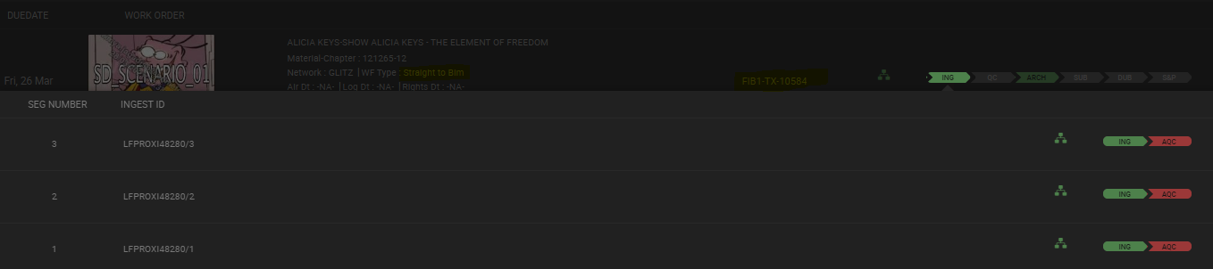

7.Audio Configuration for STB will always be Spanish-Spanish-Silence-Silence

Snell payload sample:

{"matID":"BC1KJ-A_02","lang":"OriginalLeft-OriginalRight-Silence-Silence","tapeNo":"1FIB1TX1694329","longFormId":"BC1KJ-A_02","timeCode":"01050011","mTType":"PROGRAMME","notes":"A:SPA(M)/SPA(M)/SINA(M)/SINA(M) S: (Null) M:/33/.MOV","rby":"CLEAR","oAD":"00:05:00:11","title":"NO USAR - TT - REGULAR 300-STB","cName":"NOUSARTTREGULAR300STB--20210321053622676196--652--LF--5017","TimeCodeOut":null}

* Below is the steps to login to Rhozet

i.Login to MC (134/132) and RDP to 10.185.134.170 , Below is the UI for Rhozet , check for the active , queued jobs , if there is any error will be displayed under Progress on right hand side.

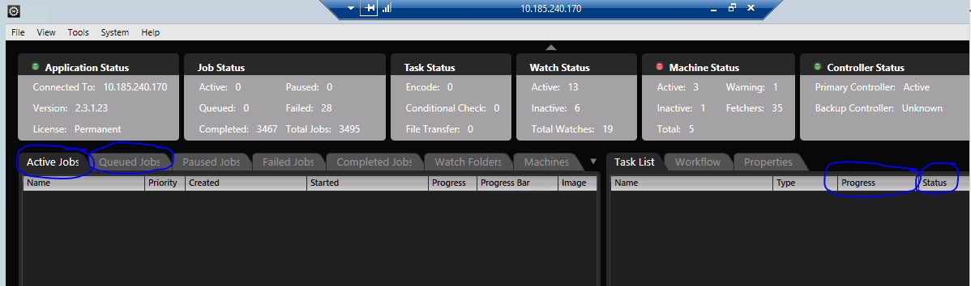

**QC only flow:**

1.QC only flow is always created manually .Navigate to Workorder dashboard🡪Click on create🡪select WF type as QCOnly.

2.Enter the Title & chapter Id on which QC only should be triggered.Select Aleph Media Id from drop down.CLEAR will call restore WF to restore the media from DIVA.

3.QC only flow creates QC task .Notification should be sent to QC team.(There is no Ingest , AQC , Archival)

4.When QC task is created , open the QC tool , it should contain the duration , segments details, Audio details of that title –chapter .

5.QC Pass , Fail , approve and reject can be performed , download the report and QC status should be updated to Aleph.

**Source in BIM**



Source in BIM workflow can be created manually from Work order dashboard or it will be triggered using Version Selection API.

* In case of Source In BIM, there won’t be any ingest , AQC , QC.
* The restore workflow to be triggered from Longform work order.

i.SIB-STB

To create from Version selection API use below:

{

"titleId": "147871", // give title id

"chapterId": "7", //give chapter id

"subTitles": [],

"feed": "GLBS", //give Feed ID

"mediaSourceId": "FIBH-MAST-1486605",

"clearWorkflowCode": "Missing Version Type"

}

* If feed Id belongs to Glitz Network, then it is just like a STB work order. Work order type need to be defaulted to be STB. Network will be populated based on feed Id.
* If GLBS /GLBR is not given in above payload , then the WF type created will be Missing Version.
* Media Management Will Perform Notify Distributer. Edit the Work order ,provide the below details under Media and Start the WF:

i.Type(TX)

ii.Format(SD)

iii.Segment(multiple segments)

iv.Aspect ratio(4:3 FULL FRAME)

v.Audio not mandatory (Audio Configuration for STB will always be Spanish-Spanish-Silence-Silence)

* Playlist should be created for the multiple segments ingested & available in Library
* WF type will SIB-STB ,if any other WF type is selected then below is the validation.
* Note : STB Workflow should be completed before triggering SIB-STB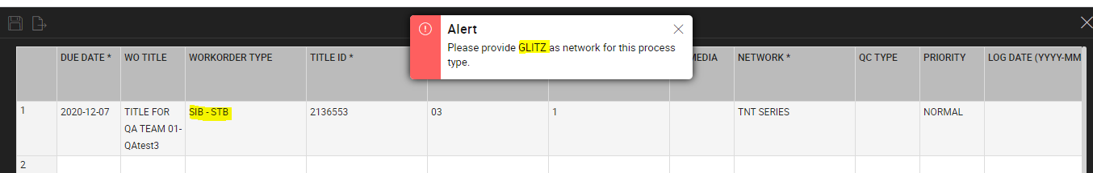



**Missing Version**

* Source in BIM (Missing Version) workflow will be created from Version Selection API and also Manual WO creation.

Below is the for Version Selection API :

{

"titleId": "147871", // give title id

"chapterId": "110", //give chapter id

"subTitles": [],

"feed": "01CS", //give Feed ID

"mediaSourceId": "FIBH-MAST-1486784", //give media id

"clearWorkflowCode": "Missing Version Type"

}

Supported Media formats: MAST , COPM

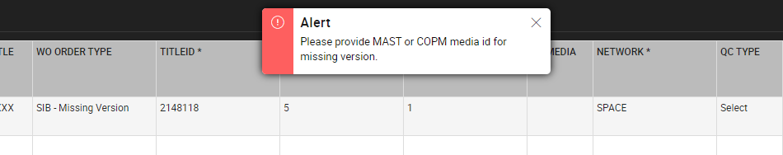

Not supported : TX (both virtual & Non-Virtual)

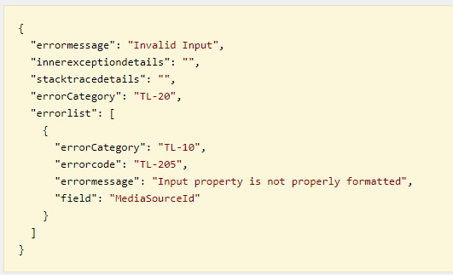

* There will not Notify distributor , only Start WF will be available, After click on start WF restore of the given media id in EditWO form will be started
* Subtitle , Dubbing & Edition details can be given in EditWO and respective tasks will be created. In S&P task Uncut can be selected /deselected.
* Missing version triggers Virtual flow if VIRH/VIR1 is given in Edition form in EditWO.
* There is no Ingest , AQC , QC in Missing version flow.
* Note: If Proxy is already available in Clear for the respective mediaId , then restore wf will not be triggered. If Proxy is not available in Clear , then Restore WF should be triggered.

**Missing Rating :**

Missing Rating workflow will be created from Version Selection API and also Manual WO creation.

Below is the payload:

{

"titleId": "147871", // give title id

"chapterId": "100", //give chapter id

"feed": "31VS", //give Feed ID

"mediaSourceId": "FIBH-TX-149653", //give media id

"clearWorkflowCode": "Missing Rating",

"timeToAir": "10:23:03" //give Time to Air

}

Supported Media formats: TX (both Non-Virtual & Virtual)

Not Supported Media formats: MAST , COPM

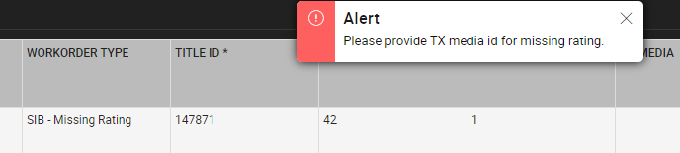

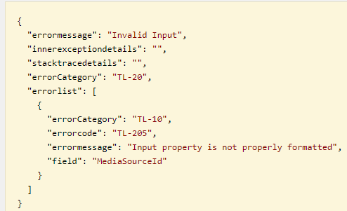

* There is no Notify distributor and Start WF .WF should restore the TX media id given version selection API or the mediaId given in EditWO incase of manual WO creation.
* Navigate to Rating Task board and perform Rating task .
* CLEAR should display “Time To Air” in the S&P Ratings Dashboard.

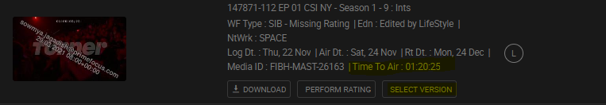

* In The Rating task , there is a version popup to trigger Missing version .If versions are selected then for the same Title and chapter id ,missing version flow will be created automatically where user edits the EditWO and click on start WF . There won’t be S&P task created ,it will create Versions task in PE .

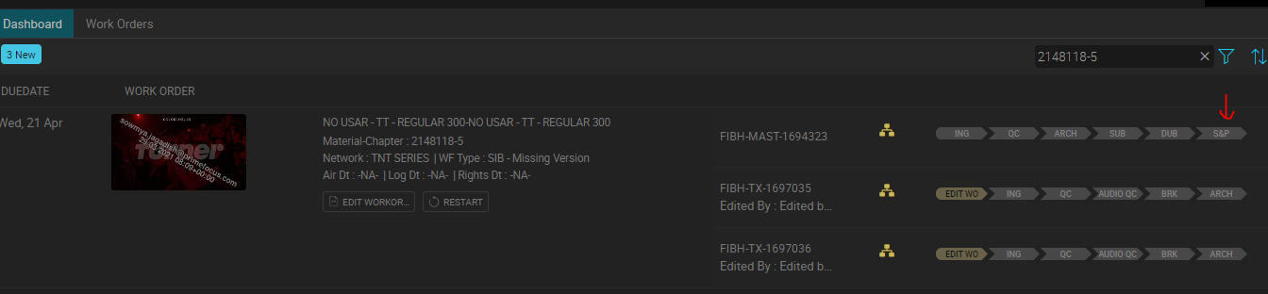

* Versions selected in Missing Rating should display in Edition form and its parent Media Id when Missing version is created .

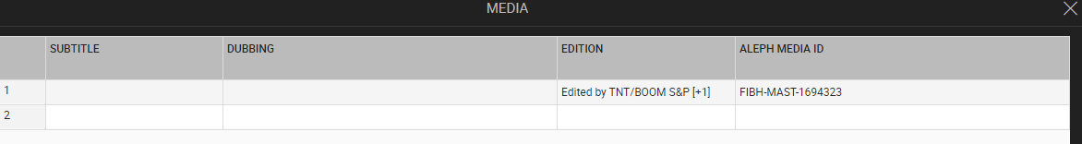

* If Versions are not selected then this WF will complete only the Missing Rating.
* Thumbnail should be updated accordingly in the Process Monitor Latam dashboard afte Restore.

Note: If Proxy is already available in Clear for the respective mediaId , then restore wf will not be triggered. If Proxy is not available in Clear , then Restore WF should be triggered.

**Missing Subtitle**

* This workflow will be created from Version Selection API and also Manual WO creation.

Below is the payload:

{

"titleId": "147871", // give title id

"chapterId": "57", //give chapter id

"subTitles": [

{

"subTitleLanguage": "INGL" //give Subtitle language

}

],

"feed": "01CS", //give Feed ID

"mediaSourceId": "FIBH-TX-1486498", //give media id

"clearWorkflowCode": "Missing Subtitle"

}

**For multiple subtitle language:**

{

"titleId": "147871",

"chapterId": "104",

"subTitles": [

{

"subTitleLanguage": "INGL",

}

{

"subTitleLanguage": "PORT"

}

],

"feed": "01CS",

"mediaSourceId": "FIBH-TX-1486237",

"clearWorkflowCode": "Missing Subtitle"

}

Supported Media formats: FIBH-TX , FIB1-TX & MAST , COPM (incase created manually)

Not Supported Media formats:, VIRH , VIR1

Note : MAST , COPM will not be supported when created from version selection API .

* Subtitle details should be given in EditWO🡪Media when created Manually and there will subtitle task created directly on TX

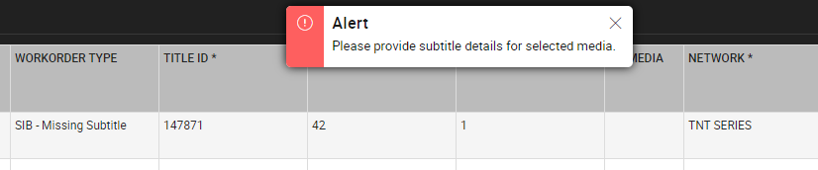

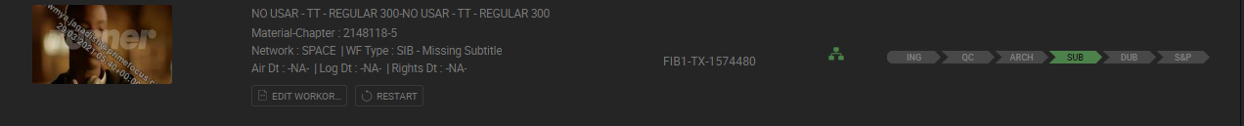

* When created from API , subtitle task wil be created on both MASTER &TX

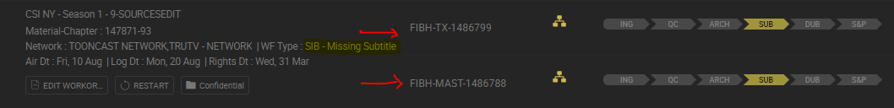

* There is no Notify distributor and Start WF .WF should restore the TX media id given version selection API or the mediaId given in EditWO incase of manual WO creation.
* WF should restore the TX media id given version selection API or the mediaId given in EditWO incase of manual WO creation.

**Not Defined:**

This workflow will be created from Version Selection API and also Manual WO creation.

{

"titleId": "147871", // give title id

"chapterId": "6", //give chapter id

"feed": "01CS", //give Feed ID

"clearWorkflowCode": "Not Defined"

}

* WF type created should be SIB-Not Defined

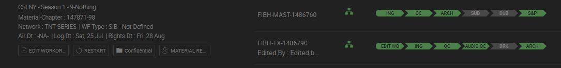

* This flow has Notify distributor & Start WF (same as in Regular)
* Edit the WO , Provide the subtitle , dubbing , Edition (FIBH/FIB1/VIRH /VIR1)
* WF works same as in Regular